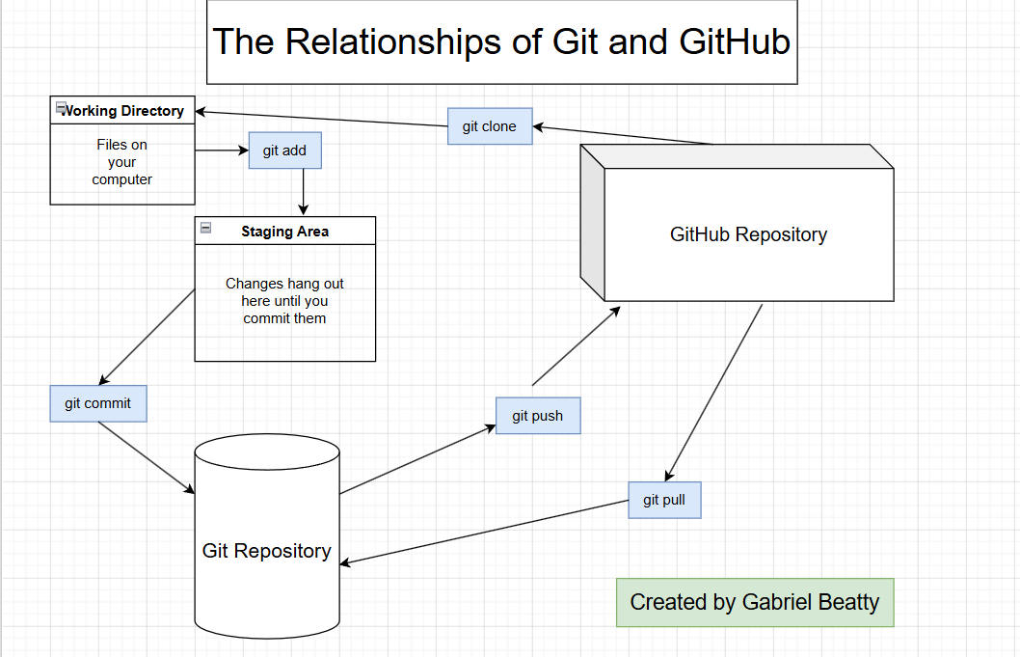
Using git clone, git push, and git pull as well as utilizing branching and merging facilitates team work within the Git/GitHub ecosystem.

